

Implementation DevOps with Git, GitHub, Jenkins, Pipeline on Project Temperature Conversation

Group : 4

Names : 1. Christian Frans Mukuan / 1920010040

2. Deyaninta Ekabriela Permata / 1920010050

Class : 3SC3

CEP CCIT

FAKULTAS TEKNIK UNIVERSITAS INDONESIA

2020

**Developed by**

1. **Christian Frans Mukuan**
2. **Deyaninta Ekabriela Permata**



**PROJECT ON**

*Implementation DevOps with Git, GitHub, Jenkins, Pipeline on Project Temperature Conversation*

**Implementation DevOps with Git, GitHub, Jenkins, Pipeline on Project Thrift Shopping Web**

Batch Code : 3SC3

Start Date : 14 Januari 2021  
End Date : 27 Januari 2021

Name of Faculty : Riza Muhammad Nurman, S.Kom

Names of Developer :

1. Christian Frans Mukuan / 1920010040
2. Deyaninta Ekabriela Permata / 1920010050

Date of Submission: 28 January 2021

**CERTIFICATE**

This is to certify that this report titled “Implementation DevOps with Git, GitHub, Jenkins, Pipeline on Project Kibo Thrift” embodies the original work done by Christian Frans Mukuan and Deyaninta Ekabriela Permata. Project in partial fulfillment of their course requirement at NIIT.

Coordinator:

Riza Muhammad Nurman, S.Kom



**ACKNOWLEDGEMENT**

First of all, thanks to Allah SWT because we can complete this Project task both in the form of a presentation. We want to deliver sincere especially for Mr. Riza Muhammah Nurman as faculty and another faculty who always help. Thank you also to fellow students who have supported, and also thank you for being fellow workers in the education at CCIT-FTUI.

The Project paper entitled ‘Kibo Thrift' the writers submits as Project's 2021 task requirements.

The hope of the writers hopefully this paper can be useful for all so that it can add knowledge and insight. The writers realize that this paper is far from perfect. Therefore, the writers expect all suggestions and criticisms from readers who are constructive for the perfection of this paper.

Depok, January 2021

Writers

**SYSTEM ANALYSIS**

**System Summary**:

Kibo Thrift is a shop that sells used clothing and other household items. Put simply, shopping means going shopping at thrift stores, garage sales, or flea markets where you will find used items at discounted prices. On this Kib Thrift website, users can view available catalogs on several pages, and then users can order through the website on the checkout page or WhatsApp by scanning the QR code in the footer section. User can also log in register for an account before make an order.

To facilitate the making of the application the authors use the implementation of DevOps using Git, GitHub, Jenskins.

**TECHNOLOGY USED**

1. **Git**

Git is a mature, actively maintained open source project originally developed in 2005 by Linus Torvalds, the famous creator of the Linux operating system kernel. A staggering number of software projects rely on Git for version control, including commercial projects as well as open source. Developers who have worked with Git are well represented in the pool of available software development talent and it works well on a wide range of operating systems and IDEs (Integrated Development Environments).

1. **GitHub**

Git is used to store the source code for a project and track the complete history of all changes to that code. It allows developers to collaborate on a project more effectively by providing tools for managing possibly conflicting changes from multiple developers. GitHub allows developers to change, adapt and improve software from its public repositories for free, but it charges for private repositories, offering various paid plans. Each public or private repository contains all of a project's files, as well as each file's revision history. Repositories can have multiple collaborators and can be either public or private.

1. **Jenkins**

Jenkins is an open source Continuous Integration server capable of orchestrating a chain of actions that help to achieve the Continuous Integration process (and not only) in an automated fashion.

It is a server-based application and requires a web server like Apache Tomcat. The reason Jenkins became so popular is that of its monitoring of repeated tasks which arise during the development of a project. For example, if your team is developing a project, Jenkins will continuously test the project builds and show the errors in early stages of development.

1. **Jenkins Pipeline**

In Jenkins, a pipeline is a group of events or jobs which are interlinked with one another in a sequence. Jenkins Pipeline is a combination of plugins that support the integration and implementation of continuous delivery pipelines using Jenkins. A pipeline has an extensible automation server for creating simple or complex delivery pipelines "as code," via pipeline DSL (Domain-specific Language).

\

sssssssssss

**DEVOPS IMPLEMENTATION**

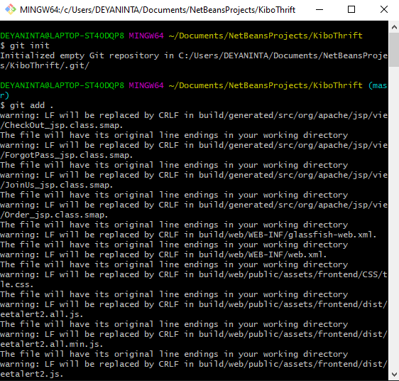 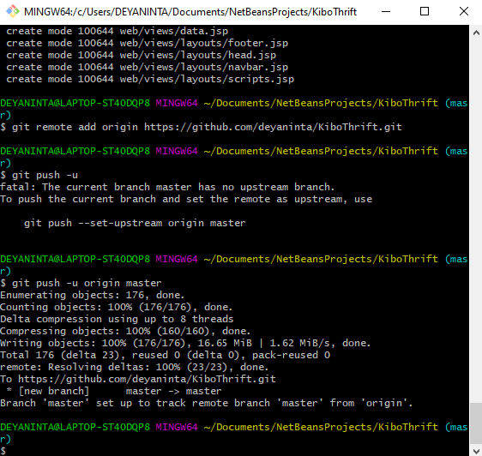

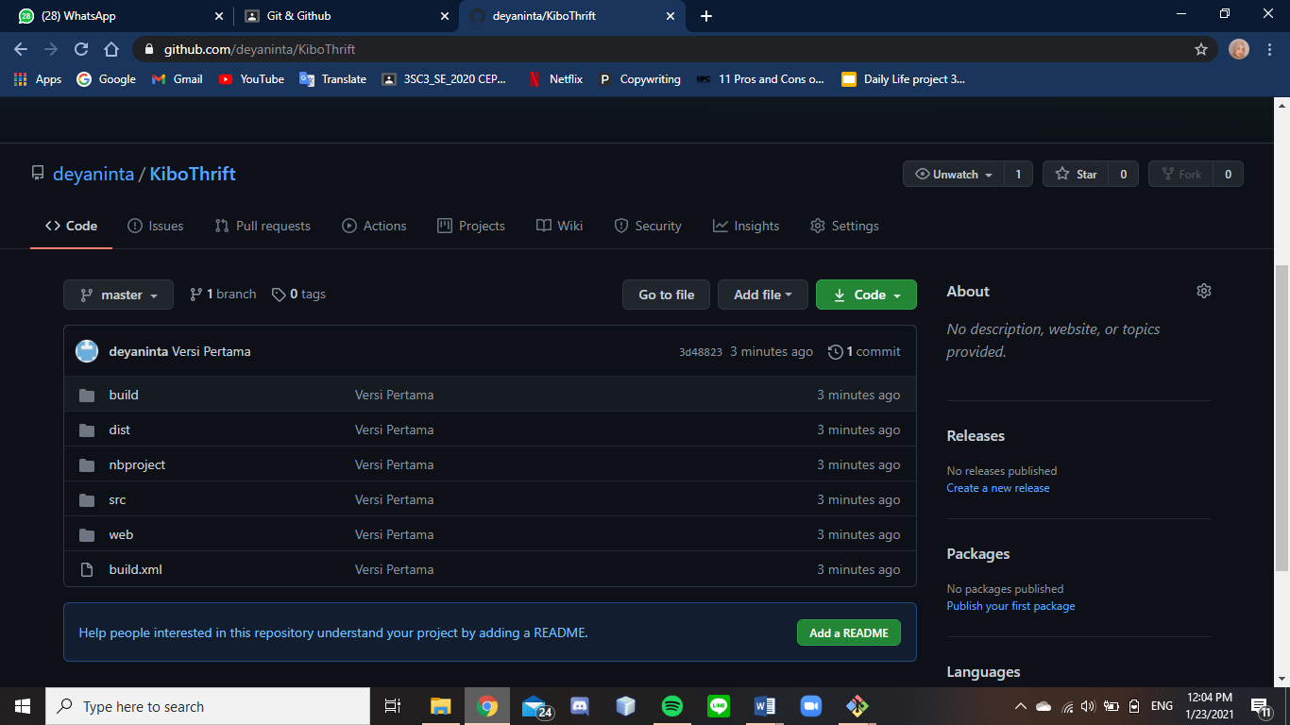

**DEVOPS IMPLEMENTATION**

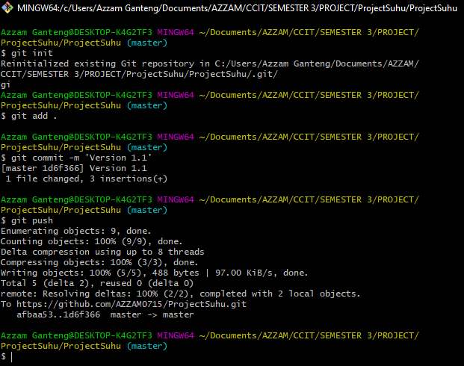

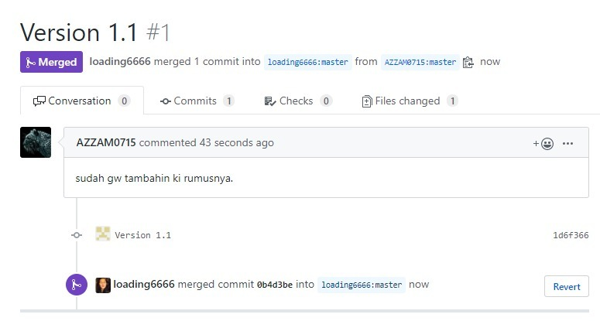

**DEVOPS IMPLEMENTATION**

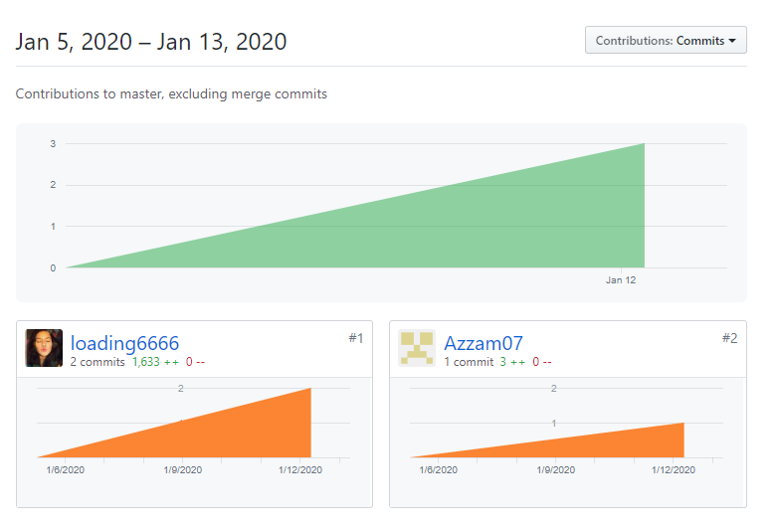

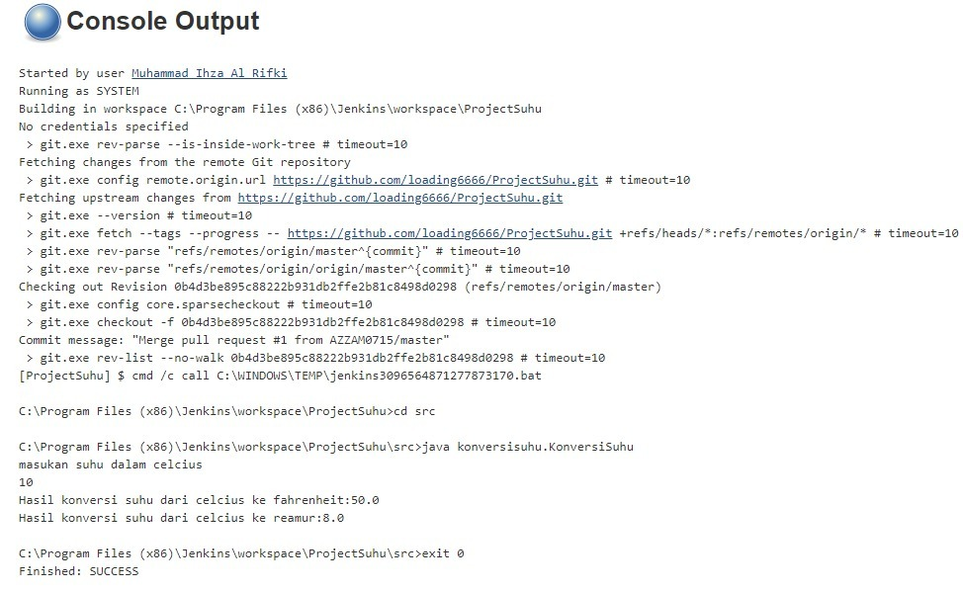

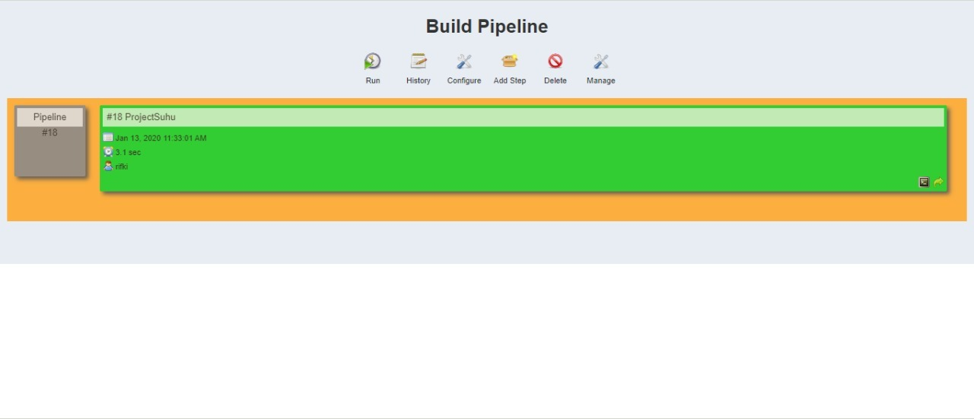

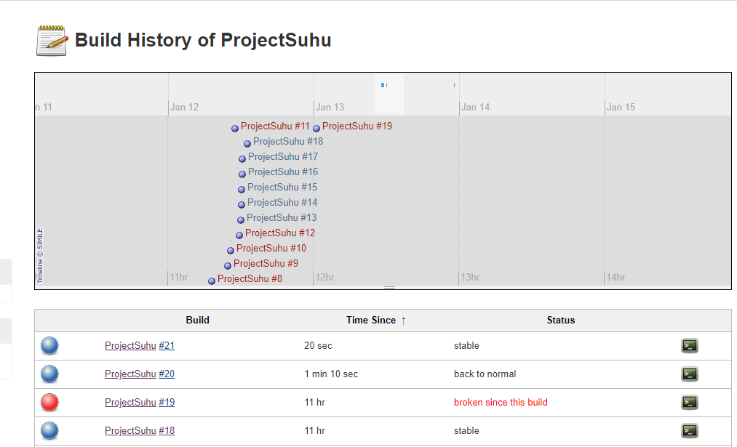

**DEVOPS IMPLEMENTATION**

|  |  |  |  |
| --- | --- | --- | --- |
| **No** | **Activity List** | **Date** | **Mark** |
| 1 | Create Temperature Convarsation apps | 13 January 2020 | Rifki |
| 2 | Create Repository using git | 13 January 2020 | Rifki |
| 3 | Add and commit to local repository | 13 January 2020 | Rifki |
| 4 | Create remote repository using GitHub | 13 January 2020 | Rifki |
| 5 | Push apps to remote repository | 13 January 2020 | Rifki |
| 6 | Forking the apps using GitHub | 13 January 2020 | Azzam |
| 7 | Cloning apps using Git | 13 January 2020 | Azzam |
| 8 | Change some code on apps | 13 January 2020 | Azzam |
| 9 | Add and commit to local repostitory | 13 January 2020 | Azzam |
| 10 | Push apps to github | 13 January 2020 | Azzam |
| 11 | Add pull request to Davi repository | 13 January 2020 | Azzam |
| 12 | Merging apps | 13 January 2020 | Rifki |
| 13 | Making new item on jenkins | 13 January 2020 | Rifki |
| 14 | Configure Jenkins | 13 January 2020 | Rifki |
| 15 | Build app on Jenkins | 13 January 2020 | Rifki |
| 16 | Making new pipeline view on Jenkins | 13 January 2020 | Rifki |
| 17 | Configure pipeline | 13 January 2020 | Rifki |
| 18 | Run pipeline view | 13 January 2020 | Rifki |

**ACTIVITY LIST**